

***THE CHIRP***

***NEWSLETTER OF THE TWIN LAKES AUDUBON SOCIETY***

**VOL 7 ISSUE 1** **twinlakesaudubon.org** **APRIL 2013 SEPTEMBER2012**

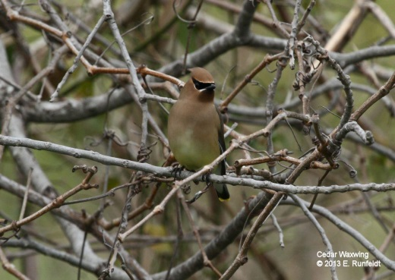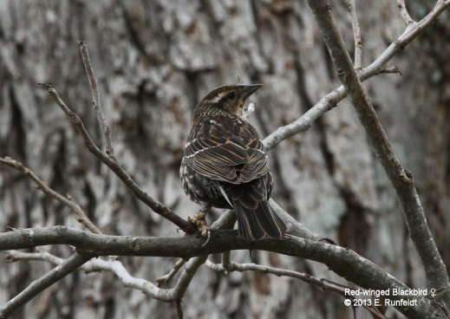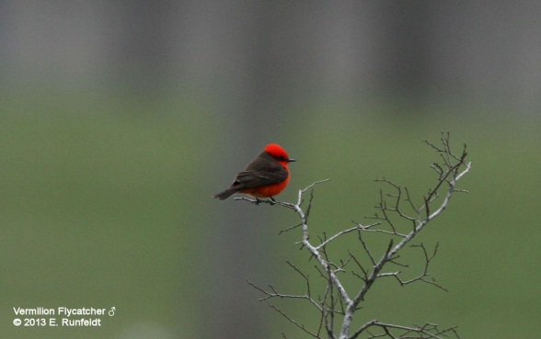

***Greetings everyone from your President***!

**F**irst, a brief recap from last month, while we did not have a meeting due to Spring Break, we did have a great field trip to a new nearby birding hotspot on March 9th. We went to Berry Springs Park and saw an excellent variety of species, including both male and female Vermilion Flycatcher, a Swamp Sparrow, a nesting pair of Red-shouldered Hawks, Red-winged Blackbirds, Cedar Waxwings, American Pipit, Red-headed Woodpecker, and numerous Pine Siskin, to name a few.

**T**his month for our guest speaker, we look forward to hearing from John Karges, Associate Director of Field Science for The Nature Conservancy of Texas.

**O**ur Field trip will be on April 20th to the Messer Ranch in Belton. It has been couple of years since we visited there, and anyone who has not been there will be delighted by the birds and Bill and Ann Messer's hospitality.

**W**e need members to fill two positions in the coming year: Vice President and Membership. Please consider volunteering, or if you know of someone who would make a great candidate, please let me know. We will discuss this more in detail during our April Meeting and we will take a vote in May!

**The dates for the Davis Mountains field trip have changed! Instead of August 9-11, the new dates are 10-12 August!** The Preserve Manager had another event imposed for the 10th, so we will travel the 10th, visit the Davis Mountains Preserve of The Nature Conservancy (bird around McIvor Center, hike into Tobe Canyon, owling and nightjars at night) on the 11th , and on Monday, the 12th visit the CDRI (Chihuahuan Desert Research Institute), and other sites before heading home. Start thinking about whether or not you want to join us on this field trip and keep your eyes open for the sign-up sheet coming soon.

**B**ack in December the Chapter voted unanimously to send a member of the Chapter to the National Audubon Convention which will take place July 12-16, 2013 at Skamania Lodge, near Stevenson, Washington. During the February meeting, the Chapter voted to give our representative $300 to cover the registration fee. With that being said, we need someone who is interested in going. Please starting thing about this and we will discuss the nominations and vote during our meeting in April.



***UPCOMING EVENTS***

Unless otherwise noted, the contact for programs and field trips is Gil Eckrich; Cell: 254-534-0061, Email is: [gil.eckrich@att.net](mailto:gil.eckrich@att.net)

**PRESENTATIONS**

9 April – John Karges, Associate Director of Field Science for The Nature Conservancy of Texas, on the selection of lands in West Texas as preserves, and the flora and fauna found there. He will feature the Davis Mountains Preserve, the site of our August field trip.

14 May - Picture Show and Tell, Everyone bring pictures to share!

**FIELD TRIPS**

20 April - T Messer Ranch

4 May - Warbler Woods

10-12 August - Summer trip to Davis Mountains

Information regarding the upcoming National Audubon Convention

The gathering will take place July 12-16, 2013 at Skamania Lodge, 45 minutes east of Portland, Oregon, near Stevenson, Washington in the spectacular Columbia River Gorge. Come celebrate the Audubon network and share your energy and passion for conserving birds throughout the flyways with leaders from across the country!

**Take a Peek - Website Unveiled Soon**

The official convention web site will open in early February, chock full of information about workshops and field trips, schedules, speakers, entertainment and local birds. In the meantime, you can find essential details at [www.audubon.org/2013convention](http://www.audubon.org/2013convention).

**Join the Flock - Attend the Convention**

All chapter leaders are strongly encouraged to consider attending the convention, as program providers and as participants. Online early bird registration will open February 11 and we will send the registration link well in advance. The registration fee will be $300/person and includes entry to weekend program sessions along with lunches, dinners and snacks from lunch on Friday through lunch on Monday, except for dinner on Sunday.

**Spread Your Wings - Field Trips and Workshops**

Friday and Monday of the convention weekend will feature exciting field trips and full/half day workshops. A detailed list will be included with registration. There will be an additional charge for field trips; most full and half day workshops will be offered at no cost to registrants.

**Feather Your Nest - Lodging**

You will need to register for housing directly with one of three convention hotels; they will begin accepting convention reservations on February 11. Each convention hotel offers complimentary breakfast. You will be able to view all hotel details on the Web site in advance of registration opening. Complimentary shuttles will be available between hotels and the convention location throughout the convention period. For budgeting purposes: shared rooms (two double beds) are available for $125-$145/night while a single room will be $125-$135/night. Additional housing options (including cabins and camping) are available nearby and we will provide details about those alternatives as well.

**Prepare to Soar - Travel and Transportation**

The closest airport to Skamania is Portland International Airport. Regular shuttles between the airport and convention hotels will be provided at no charge from Thursday afternoon through Tuesday morning. To help your travel plans, a schedule of airport and hotel shuttles will be available on the convention website.  Driving directions will also be posted.

**Recap of Key Dates:**

February 11 – Registration opens

February 15 – Program RFP’s due



**Twin Lakes Audubon Society**

P.O. Box 883

**ELECTRONIC NEWSLETTER**

All members will receive THE CHIRP electronically instead of in printed form. If a member does not have access to a computer, Please contact Carol Ann Wadley @254-771-5346 and we will gladly send you a printed copy.

As each issue goes to press, you will receive an email with a PDF of the new issue attached. The PDF is also available at our website: [www.twinlakesaudubon.org](http://www.twinlakesaudubon.org)

Belton, TX 76513

Return Service Requested

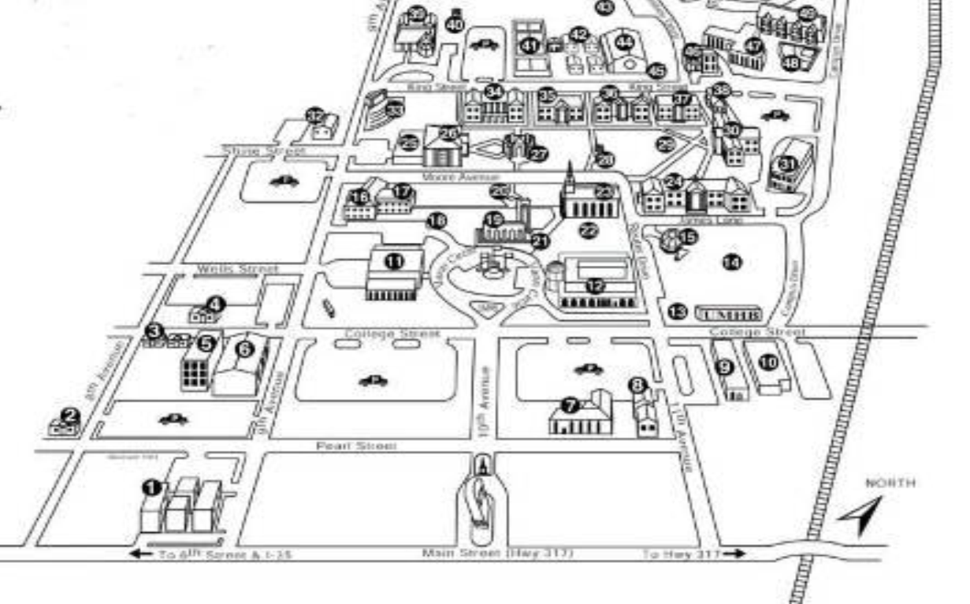

**Meetings**

7:00 p.m., second Tuesday of the month in Room 117, York Science Center, University of Mary Hardin-Baylor, Belton (No meetings March, June, July or August).